**Gamify**

**User's Manual**

**CSCI-P465/565 (Software Engineering I)**

**Project Team**

**Meghesh Patil  
Prashanth Bhat  
Sagar Panchal  
Sri Harsha**

**1. Product Overview**

Gamify is a social networking website that provides a platform for people with similar interests in sports to communicate with each other and to plan for sporting events. It allows people to communicate with each other based on their location and interests and to formulate sporting events. It comes in handy when people have to move to a different place and do not know anyone, which results in them not engaging in any sporting activity. Gamify website provides a solution to this problem as it brings people together.

People can use some of the core features like chatting to communicate with each other and to get more information about the events. There is also a facility wherein a user can post a sporting event on their wall and others in that area will be able to view it. They can like it and comment their interest via the comments section. Also, there is a facility for people to create closed groups and to have their private sporting events.

**2. System Requirements**

This product being a web application requires nothing but a web browser to run. The application can successfully run on Google chrome version: 62.0.3202, Mozilla Firefox version: 57.0.1 or Opera version: 2017. The website does not require any extensions or additional requirements.

**3. Product Installation**

The website uses PHP and MySQL database. WAMP server is used to process PHP files. Below are the links to install PHP, MySQL server, and WAMP server:

<https://www.phpmyadmin.net/downloads/>

<https://www.mysql.com/downloads/>

<https://sourceforge.net/projects/wampserver/files/>

After downloading the setup files from the above links, install the products using default settings.

Now download the code from below GitHub link: <https://github.com/prash1987/GamifyWebsite>

Copy the downloaded folder under /wamp64/www/ folder.

Now open MySQL Workbench and create a database called “gamify”. Go to www\GamifyWebsite\DB_script\ folder and run all the .sql files under MySQL workbench. This will create the required tables for the website.

Go to www\GamifyWebsite\ folder and open config.php in a Text Editor. Make sure the MySQL login credentials are correct. The credentials that you have used to install MySQL should be configured in config.php.

Once the above steps are completed, open your browser in the server and type <http://localhost:85/GamifyWebsite/index.php>. This should load the website.

Next step is to test the website from a remote system. Open a browser in the remote system and type <http://your_domain_name/GamifyWebsite/index.php> . This should load the website.

**4. Product Operation**

Using this website is very easy. To login to the website, the user can click on Login option on the top right of the page header.

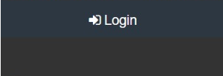

Fig. 1

Existing users can login by providing their credentials which in this case are the user name i.e. the email ID that they have provided during registration and their password.

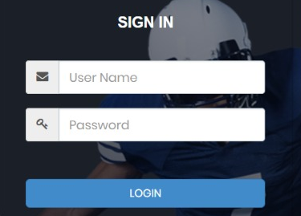

Fig. 2

A new user should click on “Register Now!” option and will be redirected to the Registration page where he/she will be able to enter their details and credentials.

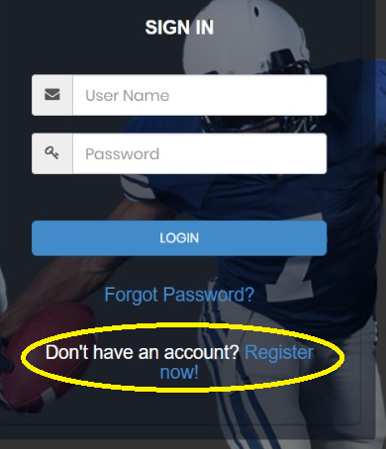

Fig. 3

Here the new user has to enter his/her email address and click on “Send OTP” button. An OTP will be sent to the user on the email provided by the user.

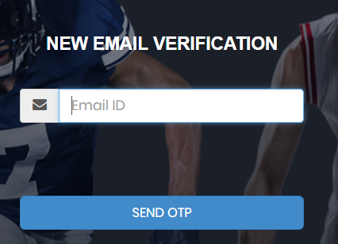

Fig. 4

Here the user will enter the OTP and click on “Verify OTP” button. If the OTP is correct then the user will be redirected to the registration page.

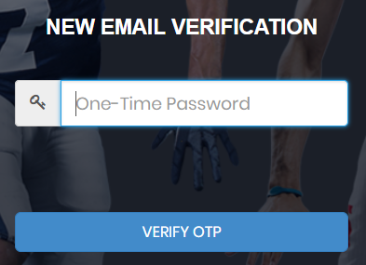

Fig. 5

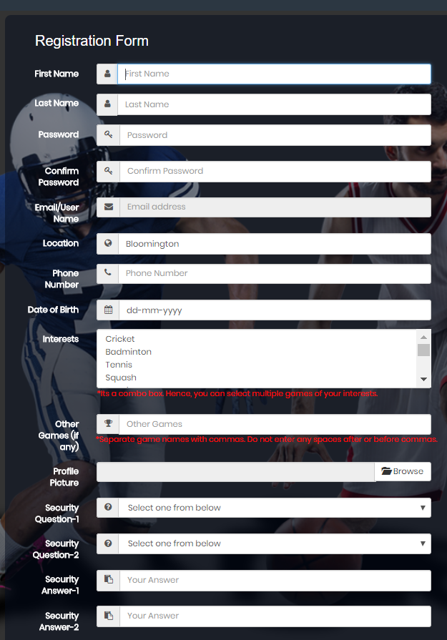

Fig. 6

Here the user will enter his/her details as per the instructions and click on the Register button. After successful registration the user will be redirected to the login page i.e. Fig 2. will be displayed.

After entering the correct credentials in Fig. 2, an OTP will be sent to the user to be authenticated again (dual authentication).

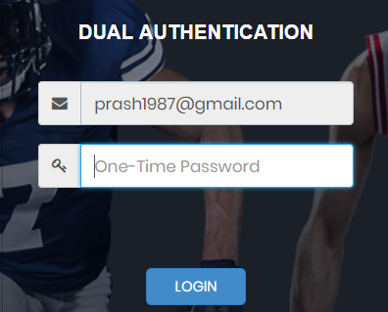

Fig. 7

After entering the correct OTP, the user will be granted access to the home page. Here the user will be able to see the post event section **Fig. 8** where the user can create a new event. The user can write some details about the event, the game for which the event is being created, gender, location, event date and time and image.

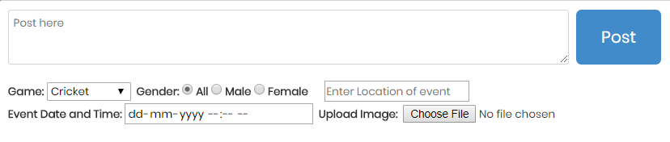

Fig. 8

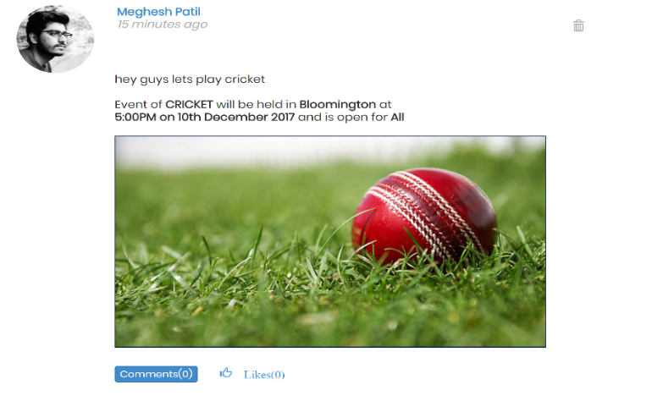

Fig. 9

The user can see posts wherein the user can like the post by clicking like button or comment on it by clicking the comment button.

To search for people, the user can make use of the search bar provided.



Fig. 10

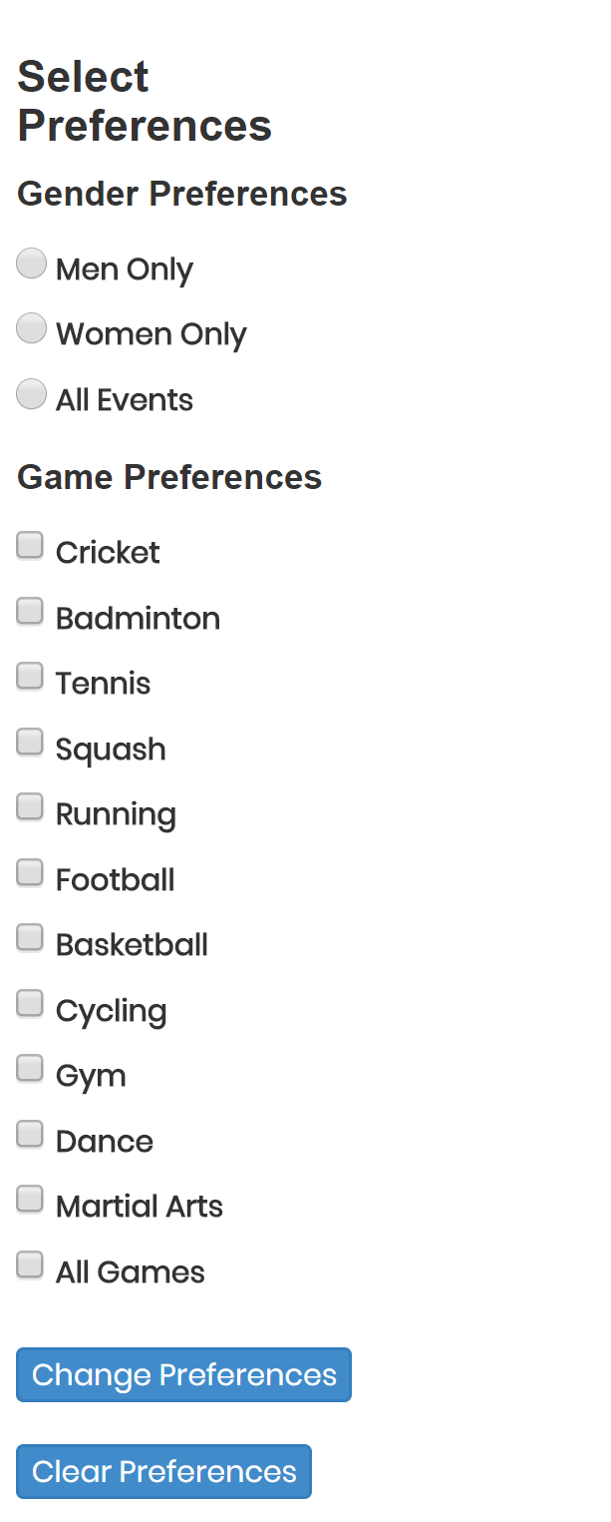

Fig 11.0

On the left side of the home page the user can view all the games. User can select multiple games and click on “Change Preferences” to view the games. Or the user can revert to his own liking of games by clearing all preferences.



Fig 11.1

On clicking the highlighted part, it will take us to the profile page of the user.



Fig 11.2

On clicking the highlighted part, it will take us to the home page of the website.

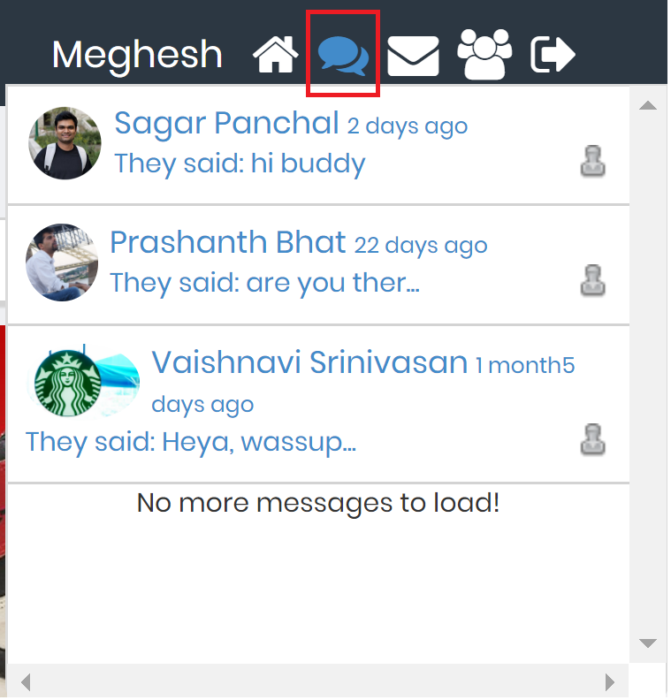

Fig 11.3

On clicking the highlighted part, it will take display the new messages that the user has received.



Fig 11.4

On clicking the highlighted part, it will take us to the message page.



Fig 11.5

On clicking the highlighted part, it will take us to the group page of the user where the user can view all the groups that the user is a part of. It will also let the user manage the groups for which he/she is the Admin.



Fig 11.6

On clicking the highlighted part, the user will logout of the website.

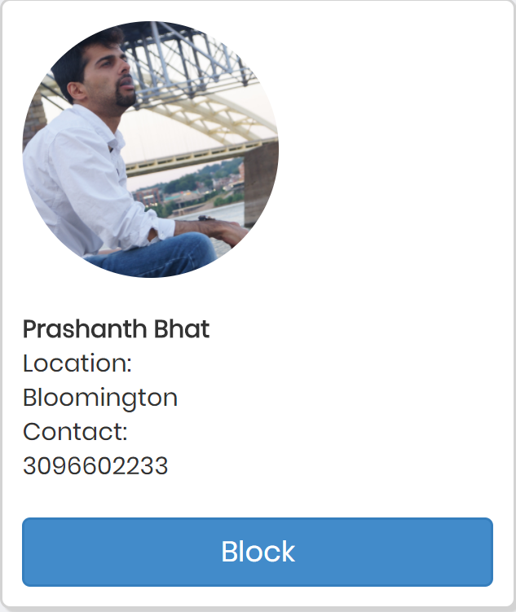

Fig 12

The user can go to any user’s profile page and block them by clicking the “Block” button.

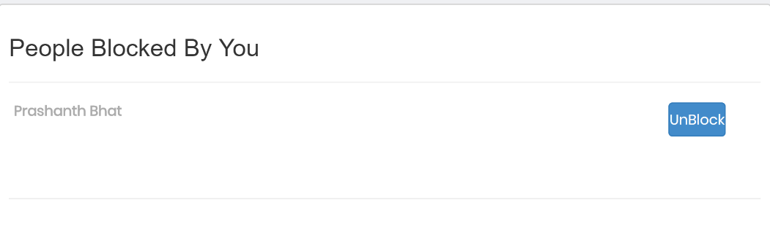

Fig 13

On clicking block button, the user will be directed to the block page where the user can see list of blocked users and option to unblock them.

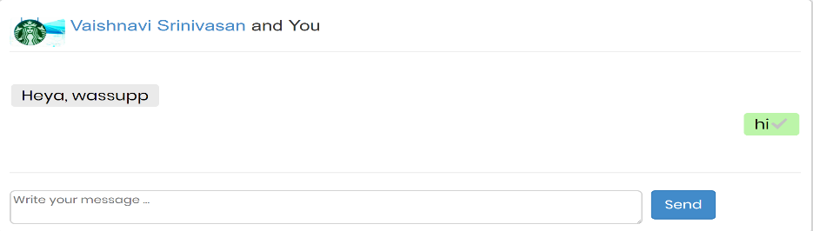

Fig 14

The user can send messages by typing their messages and clicking on send.

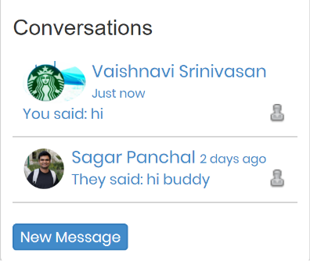

Fig 15

The user can view the latest conversations on the bottom left of the page and also chat with new users by clicking on new message button and searching for a new user.

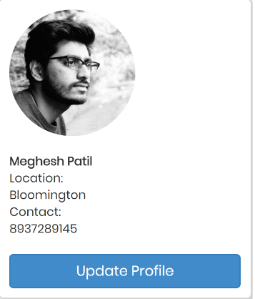

Fig 16

The user can go to their own profile page and update their profile by clicking on the “Update profile” button.

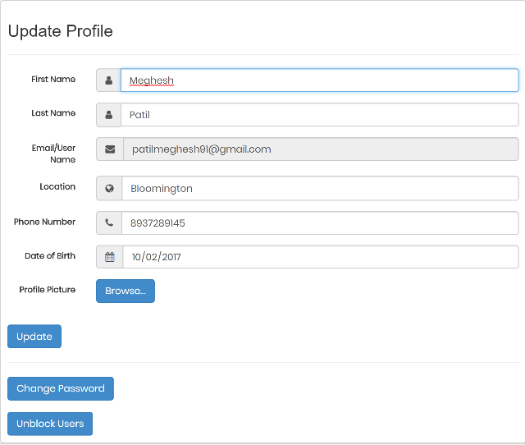

Fig 17

The user can update their details if they wish to. Here they can change their location, their phone number, profile picture, password, and also go to the block page to view who all have the users blocked.

**5. Known Defects**

1. There are few pages where we are using GET instead of POST. This is not very secure and might disclose some information to users who should not have legitimate access to it.

2. There are few pages in the website which are vulnerable to Cross Site Scripting attacks.

3. In the User Registration page, user error while entering his favorite games might result in issues during the display of posts in the homepage.

**Page Author/Creator:** **Meghesh Patil  
Last Modified:** 12/03/2017